# Quick Start Booklet

## Sales Report Window

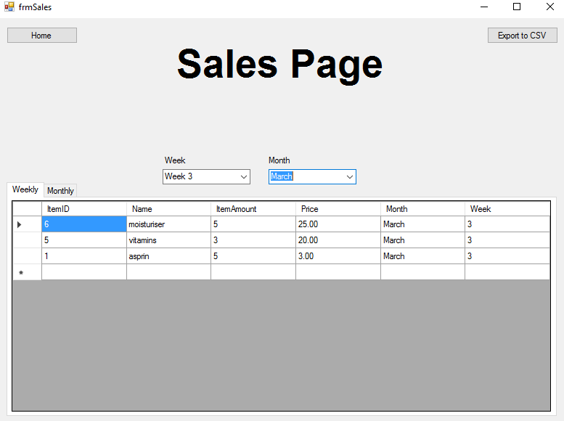

8.

7.

6.

5.

4.

3.

2.

1.

### Week Selector

The week selector allows the user to choose which week of the selected month they’d like to see the sales from.

### Month Selector

The week selector allows the user to choose the month of sales for the weekly and monthly sales tables.

### Weekly Table Tab

This table shows all the sales of the week that was selected in the weekselector of the month that was selected in the monthselector

### Monthly Table Tab

This table shows all the sales of the month that was selected in the monthselector.

### Column Heading

Clicking on the any of the Column headings will sort that column by ascending order or descending.

### Table Data

This area is where all the data is shown from the selected week and month that was selected in the selectors.

### Export Table to CSV

Clicking Export to CSV will export the current table to a .CSV format for further use.

### Home Button

Clicking the Home button will take the user back to \

## Add Sale Window

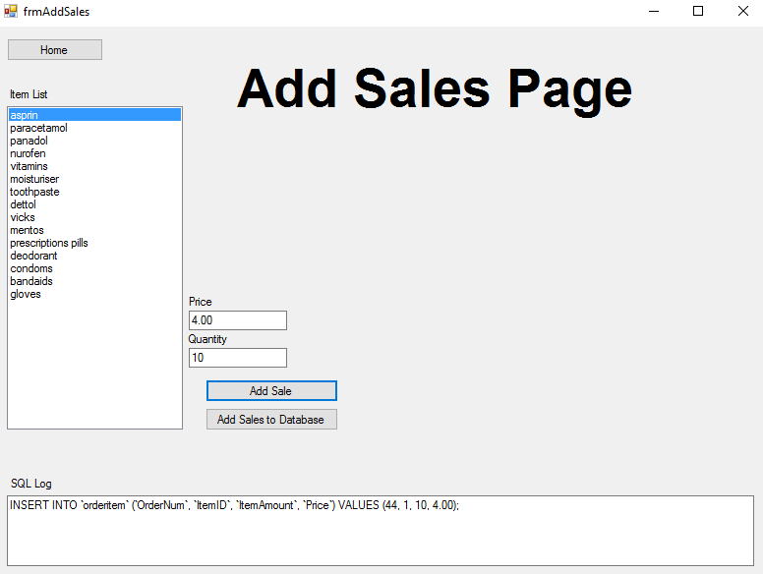

2.

6.

5.

4.

1.

7.

3.

### Item List Selector

This is a list of the current Items on the database. Click on the item you wish to add to the sale.

### Price

Type in the price of the sale. i.e. The customer bought an aspirin at the price of $4.00

### Quantity

Type in how much of the item was in the sale. i.e. The customer bought 10 vitamins during this sale

### Add Sale

Clicking Add Sale will add the sale to the SQL Log down below and await further sales.

### Add Sales to Database

Clicking Add Sales to Database will add all the sales that has been made in this instance to the database in bulk.

### SQL Log

The SQL Log shows was information is being sent to the database.

### Home Button

Clicking the Home Button will take you back to the Homepage.

## Stock Page Window

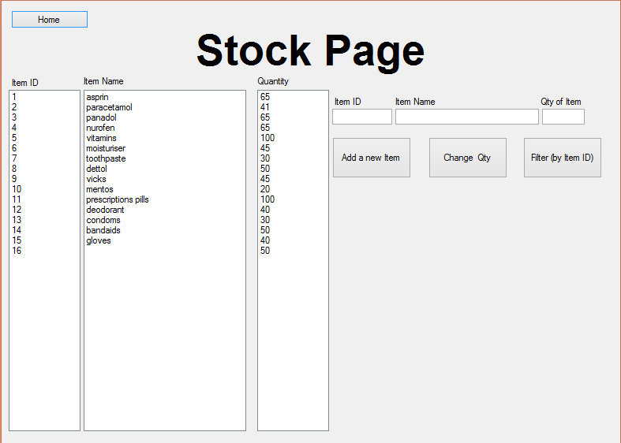

11.

10.

9.

6.

7.

5.

1.



3.

2.

4.

8.

### Add a new Item Button

Clicking the Add a new item button will add an item in the list along with its item ID, item name and the quantity of the item.

### 2. Change Qty Button

Clicking the Change Qty button will change the quantity of the specific item (Item Id of the item must be entered in the textbox of Item Id) entered in the textbox of "Qty of Item".

### 3. Filter (by Item ID) Button

Clicking this button will only show the selected Item which by whatever Item Id is entered within the textbox.

### 4. Delete Item Button

This button deletes the selected item from the list.

### 5. Qty of Item Text Box

This text box is used to enter the quantity of an item.

### 6. Item Name Text Box

This text box is used to enter the name of an item.

### 7. Item ID Text Box

This text box is used to enter the ID of an item.

### 8. Quantity List Box

This list box is used to display the quantity of the items.

### 9. Item Name List Box

This list box is used to display the name of the items.

### 10. Item ID List Box

This list box is used to display the ID of the items.

### 11. Home Button

This takes the user back to the home page.